**E115 – Programming and Data Analysis**

**Individual log sheet for Week 06**

1. Choose an item from your project (e.g. body lotion, fragrance etc) and answer the following questions. Each team member should work on a different item.
   1. Create a new Excel sheet with the following headings.

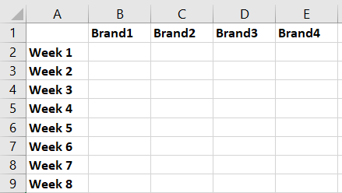

* 1. Replace “Brand1”, “Brand2” etc with the brand names that sell your chosen item.
  2. Fill in Columns B to E with the sales revenue of your item for each brand in each week.

Answer:

E.g. Shampoo & Conditioner

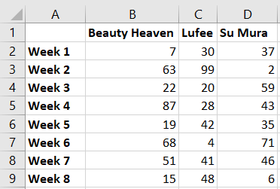

(See the attached excel macro in Question 6 for the completed file for all products, refer to Tabulate() in module 1))

1. Use Data Analysis ToolPak to create a correlation matrix for the item that you are in charge of. Identify two brands are competing against each other the most and two brands that are complementing each other the most, in terms of their sales revenue.

Answer:

E.g. Shampoo & Conditioner

|  |  |  |  |
| --- | --- | --- | --- |
|  | *Beauty Heaven* | *Lufee* | *Su Mura* |
| Beauty Heaven | 1 |  |  |
| Lufee | 0.044255 | 1 |  |
| Su Mura | 0.192452 | -0.86886 | 1 |

(See the attached excel for the completed file for all products)

Lufee and Su Mura are strongly negatively correlated. So they are competing with each other. (Note, not all products have correlation among their brands, See the attached excel macro in Question 6 for the completed correlation table for all products)

1. Plot X-Y Scatter charts to show the correlation between the brands for the item that you are in charge of.

Answer:

Su Mura and Lufee are competing with each other as the sales for one brand goes up and then the sales of the other brand goes down

(See the attached excel macro in Question 6 for all the Scatter Charts for brands which have strong correlation, refer to CorrelCoeffMatrixforAll() in module 1)

1. Consolidate your charts and correlation matrices within your team and discuss how the brands are affecting each other. What are the possible strategies that the company can adopt to improve its business?

Answer:

Totally there are 11 pairs of brands which have strong correlation for 8 type of product items.

6 pairs of brands have positive or strong positive correlation which means when the sales of brand 1 go up, then the sales of brand 2 go up either. Possible reason is that customers who like brand 1 may like brand 2 also. For this kind of product, it is better to keep the 2 brands at the same time. For example, for Hand, Foot and Nail treatment products, the company can keep the brand Beauty Heaven and Cralins at the same time

5 pair of brands have negative or strong negative correlation which means when the sales of brand 1 go up, then the sales of brand 2 go down. This could be that for the same kind of product, the two brands are too similar, a customer who chooses one product will not buy the other one probably. For this kind of product, it is better to keep one brand. For example, for Shampoo and Conditioner, the company should keep either the brand Lufee and or Su Mura.

1. Based on the correlation matrices for all the items, use Histogram to show how many pairs of brands have strong (including very strong), moderate, weak and no correlation. Based on the percentage of weak and no correlation, does the company need to worry about their brands affecting one another?

Answer:

|  |  |  |  |  |  |
| --- | --- | --- | --- | --- | --- |
|  |  |  |  |  |  |
|  | *Bin* | *Frequency* | *Cumulative %* |  |  |
| No | 0.2 | 45 | 42.06% |  |  |
| Weak | 0.4 | 32 | 71.96% |  |  |
| Moderate | 0.6 | 19 | 89.72% |  |  |
| Strong | 0.8 | 9 | 98.13% |  |  |
| Very Strong | More | 2 | 100.00% |  |  |
|  |  |  |  |  |  |

See the attached excel macro in Question 6 for the data, result and script (CorrelCoeffHistogram*()* in module 1, used to prepare data only)

For students, they can code to prepare the data or manually prepare it.

Nearly 72% of pairs of brands have weak or no correlation.

Only 10% of pairs of brands have strong correlation

Thus, overall, no need to worry about brands are affecting each other too much! Of course, it also depends on the revenue for the 10% of brands. For advanced students, they should also look at the pie chart in the previous lesson to make better conclusion here.

**Stretch question to challenge yourself (optional)**

1. Write a VBA macro to perform the tasks in the Qn1, Qn 2 and Qn 3 for all the products. Verify your results for each product with the results obtained from your team’s consolidated results

Ans:



Note: When you open the attached file, please save and change the filename as “LogSheet Ans”, before you can run the macro

Otherwise, you have to manually update the script with your new file

Workbooks("LogSheet Ans").Worksheets("LogS - Qn6 -Result").Activate

Set Wksheet = Workbooks("LogSheet Ans").Worksheets("LogS - Qn6 -Result")